LAB MODULE 1: TECHNIQUES IN DNA TRANSFER

I. BACKGROUND

INTRODUCTION
Working with DNA, solutions containing DNA, or reagents used to modify or react with DNA in the laboratory requires careful attention to technique. This technique often involves the use of micropipettors and small solution volumes. Therefore, mastering the art of using micropipettors and how to transfer small volumes of solutions is critical before doing any laboratories related to DNA science. If you work in any career related to DNA in a laboratory, you will likely use a micropipettor often. You will also need to become comfortable with transferring small volumes to small tubes called microcentrifuge tubes and/or even smaller tubes used for polymerase chain reaction experiments (PCR). The use of microcentrifuges to “spin down” or separate solutions or reaction portions during DNA isolation or other experiments is also a common technique that this lab will introduce. Today’s lab should help you become familiar and comfortable with techniques and equipment.

CAREERS IN DNA SCIENCE RELATED TO THIS LAB
Since this laboratory module is designed to help you learn a technique used in almost all DNA science careers, this laboratory could prepare you for a broad range on science careers such as a Cancer Researcher, Pharmaceutical Scientist, Medical Doctor, Forensic Scientist, or Genetics Research Scientist to name just a few categories. You will get a chance to explore careers related to DNA Science in the career spotlight portion of each module.
Career Spotlight:
CNN reports: Killing cancer like the common cold. Ctrl + Click on image for the link to this article and video or click on this link. http://www.cnn.com/2013/12/07/health/cohen-cancer-study/
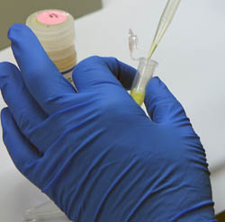

YOUR PRE-LAB E-PORTFOLIO ASSIGNMENT
- This laboratory module includes a section called “General Laboratory Techniques” which you will need to read over prior to lab.
After reading the “General Laboratory Techniques” handout, please answer the following questions prior to laboratory .
- What volumes can you pipet with a micropipettor like the P20 shown in the module?
- What pipet tips are matched with each size of micropipettor?
- Why do you think disposable plastics like pipet tips and microcentrifuge tubes are used so often in laboratories and experiments working with DNA?
- Check out the video on Pipetting 101. VIDEO

II. OBJECTIVES OF THIS LABORATORY ACTIVITY
- To learn techniques and practices in DNA and small solution volume transfer.
- To learn how to appropriately use a micropipettor, microcentrifuge, and small volume microcentrifuge tubes.
- To begin understanding common techniques related to the maintenance and care of DNA reagents and other biochemicals in the laboratory.

III. GENERAL LABORATORY TECHNIQUES

BACKGROUND ON USE OF MICROPIPETTES

Why is it important to pipet correctly
- Biochemical reactions in the laboratory are controlled events that occur as a result of mixing reagents at the correct concentrations and proportions.
- Inaccurate volumes from incorrect use of pipettes will result in suboptimum concentration of a given reagent in a reaction.
- Incorrect volumes of a given reagent will result in one or more of the following:
- waste of reagents and time,
- less than optimum amount of products,
- no products,
- undesired side reactions,
- Results that cannot be reproduced.
- Inappropriate use of pipettes can result in cross-contamination of samples.

Becoming familiar with the instrument
- There are many commercially available pipettes: many brands, many models (electrical, mechanical), and many sizes.
- The mechanical Gilson micropipette family:

Size (name) | Pipetting range(μl)
P-10 | 0.5-10
P-20 | 1-20
P-200 | 20-200
P-1000 | 200-1000
P-5000 | 1000-5000
Note: The maximum volume that a pipet is designed to draw is shown on the plunger button. Attempting to pipet smaller volumes than those indicated for a given pipet size will result in inaccurate delivery of volumes. Also, setting the volume adjustment window to larger volumes than those indicated will result in disassembling of the plunger and therefore decalibration of the pipet.
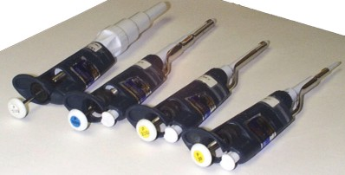

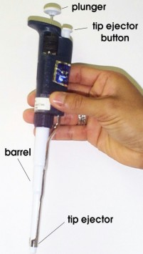
Basic parts of micropipettes (please see this and the figure below)

- plunger
- tip ejector button
- barrel
- tip ejector
- volume-adjustment window
- volume-adjustment wheel

-Volume adjustment window: three places

Pipette size | First place (top) | Second place | Third place
P-10 | 10’s | 1’s | 0.1’s
P-20 | 10’s | 1’s | 0.1’s
P-200 | 100’s | 10’s | 1’s
P-1000 | 1000’s | 100’s | 10’s
P-5000 | 1000’s | 100’s | 10’s

-For example, in the figure below, the volume adjustment window reads 0, 5, 0 from top to bottom in a P-1000 pipette. Therefore, the pipet is set to draw 500 μl.

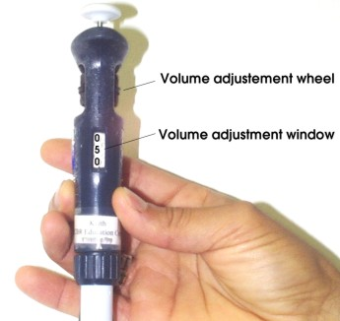

Pipette maintenance

- Do not autoclave
- Avoid dropping
- Never attempt turning the volume adjustment wheel beyond the maximum volume in its range.
- Avoid introducing solutions into the pipette barrel (i.e., beyond the tip). This might happen when the pipet plunger is released to quickly as samples are being drawn into the tip.
- Rinse well with water after pipetting corrosive materials. Let dry.
- Calibrate periodically (6-12 months depending on use), or after misuse.
- Change seals at every calibration

Choosing pipet tips

Micropipette tips are available in either prepacked plastic boxes (such as the ones shown below) or in bulk bags that require loading onto reusable boxes.

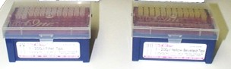

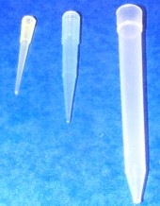
Match the tip to the pipet:
- small (for P-10, P-20 and P-200)
- medium (for P-1000)
- large (for P-5000)

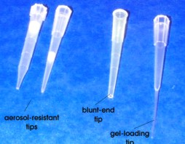
Match the tip to the job:
- common tips (above)
- aerosol-resistant tips
- blund-end tips
- gel-loading tips

Pipetting correctly
- Decide on the volume and solution to be pipetted.
- Identify the pipette size and the type of tip needed.
- Attach the tip to the pipette by pressing firmly while introducing the bottom of the barrel into the large aperture of the tip.
- Identify the stock solution from which you will be pipetting.
- Press plunger down to the first stop (point of greater resistance), and slowly release the plunger to withdraw the solution into the tip. Fast plunger release will cause solution to rush into the sides of the tip and/or the pipette barrel. This will result not only in inaccurate volume delivery, but also in potential contamination of other samples and rapid pipette deterioration.
Note: Viscous solutions must be pipetted very slowly in order to ensure accurate volume uptake and delivery. When pipetting mixtures containing reagents such as glycerol or triton X-100, the pipette tip much be rinsed thoroughly in the mixture in order to ensure complete delivery of the pipetted volume.
- Identify the tube into which the solution will be delivered.
- Introduce pipette tip into the bottom of receiving tube. While having the tip touch the side of the tube, press plunger slowly to the first stop to push solution out of the tip. Continue to hold plunger down.
- Eject the last residues of the solution by raising pipette tip just above the solution. While still touching the side of the tube, press plunger to the second stop.
- Make sure that the tip is above the solution, then release the plunger.

IMPORTANT LABORATORY HABITS

Setting-up reactions
- Maintain bench area clean to minimize reagent contamination.
- Always change pipette tips for every reagent.
- Use “aerosol resistant tips” setting up highly sensitive reactions (e.g., PCR, RNA work).
- Add enzymes last when setting-up reactions involving this type of reagent.
- Mix reagents well by vortexing or carefully pipetting in and out. Pulse centrifuge before incubating to collect reagents in the bottom of the tube.

HANDLING OF MOLECULAR BIOLOGY REAGENTS/SOLUTIONS

Types of Molecular Biology reagents

Note: Always read product information
- Temperature-labile reagents. These are stored at 4ºC, -20ºC, –80ºC, or under liquid N₂.
- Thermostable reagents. These are stored at room temperature. Often, thermostable reagents are stored in cold to further improve their stability and to avoid bacterial growth.
- Reagents that require desiccation due to their reactive with moisture in the air. These have to be stored in an inert gas environment.

Handling of special cases

- Use blunt-end tips to avoid shearing (breaking into smaller pieces) of high molecular weight DNA.
- RNA solutions must be handled in an RNAse-free environment (i.e., aerosol-resistant and RNAase-free tips, RNAase-free tubes, etc.)
- Mix well and pipet insoluble reagents that form suspensions (e.g., resins). Quick sedimentation of these reagents will compromise accuracy during reaction set-up.

Handling of enzymes

- Most enzymes are thermolabile and stored in cold. When using enzymes, remove from storage directly onto an ice bucket.
- If frozen, allow enzyme solutions to thaw completely over ice.
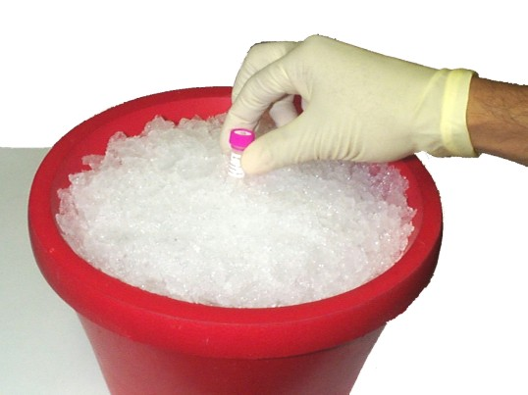

- Keep tubes on ice while pipetting from enzyme stocks.
- Minimize the number of times that thermolabile enzymes are thawed, as they lose activity every time this is done. If necessary, make aliquots of stocks at volumes similar to those expected to be used whenever the enzyme is needed.
- Never hold enzymes tubes from the bottom as to allow heat transfer from your finger tips to the solution.
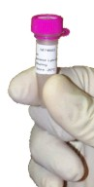
Don't do this!

Beware of the insoluble

- Some buffer mixtures contain insoluble components. Aggressive mixing and some heating are often necessary.

Warning: aggressive mixing and/or heating could adversely affect the stability of your reagent, if not done carefully.

- Some enzyme buffers may have components that become insoluble upon storage.
- Failure to fully solubilize all components of a solution will result in incorrect reagent proportions during reaction set-up.

IV. PROCEDURE / ACTIVITIES FOR THIS LAB MODULE:
After reading the above guidelines and pointers related to micropipetting and DNA lab techniques, and performing your pre-lab ePortfolio assignment, you will engage with your instructors and lab partners to perform the following activities. Please record any observations, answers to questions in the procedure, or questions you have about the laboratory for later entry into your ePortfolio.

****Lab Activity 1: (Basic Micropipetting and Microcentrifuge)
1. Obtain a microfuge tube rack and 10 separate 2.0 ml microcentrifuge tubes.
2. Practice pipetting according to the guidelines above and the instruction of your instructors.
3. Label each of the microcentrifuge tubes with numbers 1-10, consecutively.
4. To each tube, pipette exactly 90 microliters of water from the provided tubes, using good micropipetting technique.
5. Next, add 15 microliters of loading dye to tubes number 1-10 and mix well following the technique of your instructor(s).
6. Put your initials on tubes 1 and 2, then place the tubes (balanced) opposite each other in the microcentrifuge and spin for 2 minutes at maximum speed.
7. Observe and record your results.

•SIDE NOTE: WHY DO WE USE SO MUCH DISPOSABLE PLASTIC (TIPS AND TUBES) IN A DNA LABORATORY? Plastic is an inexpensive way of making sure that each tip or tube is sterile, clean, and free of DNA contamination (from bacteria, fungi, humans, or the Bojangles you had last night!) Also, each piece of plastic is uniform and consistent in how it interacts with the micropipettor. The tips and tubes are heated while molded by the manufacturer and insured to be free of enzymes that might degrade DNA and RNA in the lab (DNAases and RNAases). For a crime lab, they may also be certified to be DNA free or contamination free and prewrapped and sealed to only be opened by the researcher.

****Lab Activity 2: (More Micropipetting Practice)

Learning to Use Micropipettes: Making Suncatchers

Background
To get pipetting practice for upcoming labs, we will pipette different colored liquids to form a picture using a 96 well plate and reading a coordinate system. Just like the game Battleship, 96‐well plates have letters and numbers to note the location of individual wells. The first well in the upper left corner is A1, below that is B1 and so on. A scientist can use these coordinates to separate 96 different experiments in this small space.
The purpose of this lab is to get each student ready for the next set of labs by practicing micropipetting.

Protocol
1. Obtain the coordinate instructions for the picture that you will create (see below).
2. Figure out which colors will be used in your picture choice. Most colors are provided but feel free to make your own by mixing.
3. If the color has been provided for you, pipette 150 ul of that colored solution into the appropriate well (s).
4. If you have to mix colors to create the color (i.e., Blue + Yellow = Green) use 75 ul of each color for a total volume of 150ul.
5. When finished with your pipetting, determine what picture was created.

Coordinate instructions images:

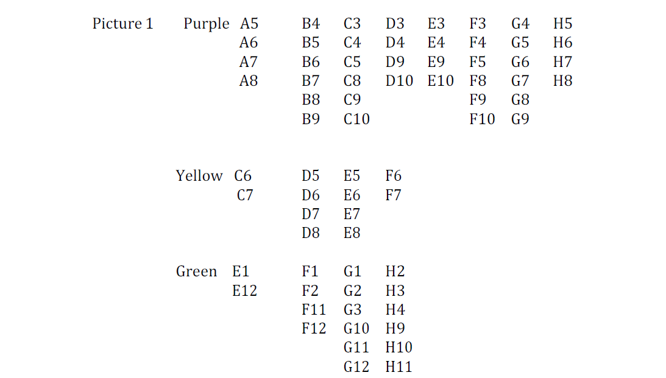

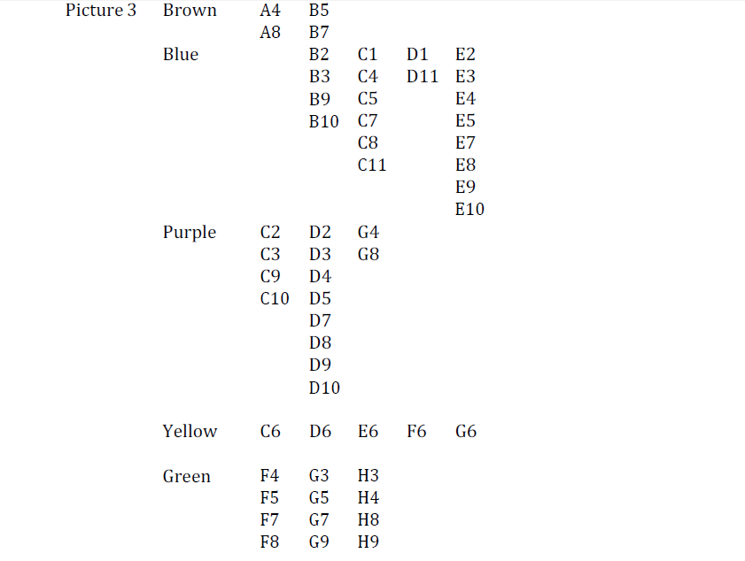

V. POST-LAB E-PORTFOLIO ASSIGNMENT

1. Name two uses for a microcentrifuge as a common tool in a DNA laboratory.
2. In a few sentences, describe what you learned from this laboratory exercise.
3. After performing this laboratory, what types of experiments do you look forward to doing next?

Please answer the questions below and return to Project GENES

School_______________________ Name______________________________

1. What are micropipettes?

2. What is a microcentrifuge used for in a DNA laboratory?

3. In a few sentences, describe what you learned from this laboratory exercise.

4. Which of the following best describes your level of understanding of the content of this module (circle answer)?
0-I do not understand the content at all.
1-I have a limited understanding of the content.
2-I understand the content well, but might have some difficulty explaining it.
3-I understand the content well enough to explain it to someone else.

5. Which of the following best describes your current level of interest in science (circle answer)?
0-I have no interest in science.
1-I have little interest in science.
2-I have moderate interest in science.
3- I am highly interested in science.

6. As of today, how would you rate your interest in a career in science (circle answer)?
1-I have no interest in a career in science.
2-I would consider a career in science.
3-I am likely to pursue a career in science.
4-I am certain that I will pursue a career in science.

